Research PAPER TEMPLATE
Name Surname, Name Surname and Author Three
Affiliation (institution, department)
E-mail of the corresponding author

Abstract. An abstract not exceeding 200 words and reflecting the essence, content and research results - formatting: spaced 1.5 lines, 10 point Times New Roman font.
Keywords: up to 5 items can be included — formatting: spaced 1.5 lines, 8 point Times New Roman font.
Introduction. The introduction includes a literature review, topicality, hypothesis or research questions. Formatting: single columns, 12 point Times New Roman font.
Data and methods. It includes a description of the experimental design, data and materials used in the research, and methods used for the analysis.
Results. This part includes key findings and can include text, tables, figures etc. Formatting: spaced 1.5 lines, 12 point Times New Roman font.

Figures – in black and white, background not shaded. Titles of figures are placed below the figures (Figure 1). Figures shall be centred.
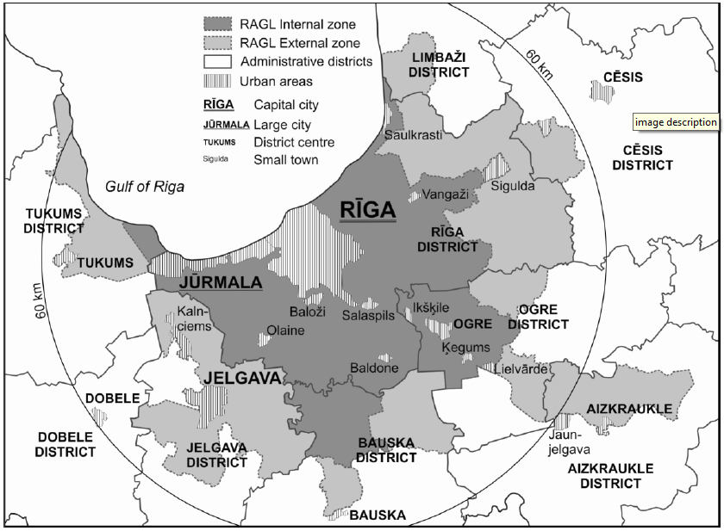
Figure 1. Spatial structure of Riga agglomeration (Departament of Human geography, University of Latvia, 2004)

Tables in the paper shall be given in Arabic numerals. The table’s title is centred in a new paragraph.
Table 1. Number of registered passenger cars per 1,000 residents
Year | Latvia | Rīga | Lithuania | Vilnius
1985 | 70 | 83 | 96 | 73
1990 | 136 | 109 | 158 | 107
1995 | 134 | 145 | 198 | 226

Conclusion. A conclusion should remind the reader of the main ideas and arguments presented and discussed in the paper. It can also suggest possible future research on the topic — formatting: spaced 1.5 lines, 12 point Times New Roman font.

Summary. Reflects the essence, content and research results in Latvian -formatting: spaced 1.5 lines, 10 point Times New Roman font.

References. When cited in the text, references to published materials must be written as follows: (Gregory 2000; Rutkis (ed.) 1967; Rediscovering Geography Committee 1997). In the list at the end of the manuscript, they should be arranged in alphabetical order. Names of journals and separate books should be written in italics. In case of web page use, the address should be noted in the reference list (by specifying the date when it was accessed). Formatting: single columns, spaced 1.5 lines, 10 point Times New Roman font.
Dansereau, P. (1966). Ecological impact and human ecology. Darling, F.F. and Milton, J.P. (eds.) Future environment of North America. New York: Natural History Press Garden City, 425-462.
Gregory, K. (2000). The changing nature of physical geography. London: Arnold.
Latvijas zeme, daba, tauta, I-III, (1936-1937). Rīga: Valters un Rapa.
Lewis, M.W. (2000). Global ignorance. The Geographical Review, 90 (40), 603-628.
Rediscovering Geography Committee (1997). Rediscovering geography. New relevance for science and society. Washington DC: National Academy Press.
Rutkis, J. (ed.) (1967). Latvia: country and people. Stockholm: Latvian National Foundation.
Centrālā statistikas pārvalde. Galvenie statistikas rādītāji 2017.gadā: http://www.csb.gov.lv/sites/default/files/publikacijas/2015/nr_03_Latvija_2015_galvenie_statistikas_raditaji_15_00.pdf (18.01.2019)

General guidelines for authors: the paper may not exceed eight pages and 3000 words.
Papers submitted for publication shall conform to the standard language (British English, Roman script) usage requirements, be edited and proofread.

